 | · October 2023 ·
∙ Sunday ∙ | ∙ Monday ∙ | ∙ Tuesday ∙ | ∙ Wednesday ∙ | ∙ Thursday ∙ | ∙ Friday ∙ | ∙ Saturday ∙
1  9:30am Catholic Devotion & Communion (GR  )  3:00pm Bible Fellowship Service (GR) | 2  10:00am Strength Training (GR)  10:45am Hymn Singing (GR)  2:00pm Apple Cider Social (GR)  2:30pm Bingo (GR)  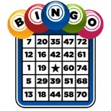 | 3  10:00am Chair Cardio (GR)  10:45am hymn singing (GR)  2:00pm Bible Study & Hymn Singing (GR) | 4  10:00am Chair Yoga & Guided Meditation (GR)  1:30pm Rosary with Jane (GR)  1:30pm Baking with Wanda (H4)  3:15pm Sing Along with Al (GR) | 5  10:00am Chair Drumming with Little Learner’s (GR)  10:45am Hymn Singing (GR)  2:00pm Did You Know? Animal Facts (H3 & H5) | 6  No Morning Activities  2:00pm Entertainment by DonLin Country (GR) | 7
8 | 9  Happy Thanksgiving  No Activities Today | 10  10:00am Chair Cardio (GR)  10:45am hymn singing (GR)  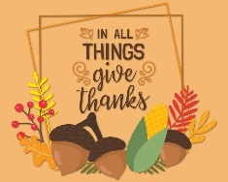  2:00pm Thanksgiving Social (GR) | 11  10:00am Chair Yoga & Guided Meditation (GR)  1:30pm Rosary with Jane (GR)  2:00pm Riddles & Brain Teasers  (H3 & H6)  3:15pm Sing Along with Al (GR) | 12  10:00am Chair Dancing: Disco (GR)  10:45am Hymn Singing (GR)  2:00pm Travel Cinema: Spain (GR) | 13  10:00am Core & Balance (GR)  10:45am Hymn Singing (GR)  2:00pm Entertainment: Don Balzer (GR)  3:30pm Catholic Communion with Father Peter (GR) | 14
15  9:30am Catholic Devotion & Communion (GR)  3:00pm Diamond House Fellowship Service (GR) | 16  10:00am Strength Training (GR)  10:45am Hymn Singing (GR)  2:00pm Hot Chocolate Social (GR)  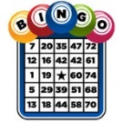  2:30pm Bingo (GR) | 17  10:00am Chair Cardio (GR)  10:45am hymn singing (GR)  2:00pm Bible Study & Hymn Singing (GR) | 18  10:00am Chair Drumming with Little Learners’ (GR)  10:45am Hymn Singing (GR)  1:30pm Rosary with Jane (GR)  1:30pm Baking with Wanda (H5)  3:15pm Sing Along with Al (GR) | 19  10:00am Chair Yoga & Guided Meditation (GR)  2:00pm Travel Cinema: Alaska (GR) | 20  10:00am Core & Balance (GR)  10:45am Hymn Singing (GR)  2:00pm Balloon Badminton (GR)  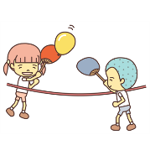  2:30pm Happy Hour (GR) | 21
22 | 23  10:00am Strength Training (GR)  10:45am Hymn Singing (GR)  2:00pm Coffee Social (GR)  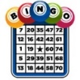  2:30pm Bingo (GR) | 24  10:00am Chair Cardio (GR)  10:45am hymn singing (GR)  2:00pm Tik Tok: Diamond House Crew (GR) | 25  10:00am Chair Yoga & Guided Meditation (GR)  1:30pm Rosary with Jane (GR)  2:00pm Poetry Club: October Poems (H4 & H5)  3:15pm Sing Along with Al (GR) | 26  10:00am Resident Birthday Party & Bingo (GR)  H1, H3 & H5 | 27  10:00am Core & Balance (GR)  10:45am Hymn Singing (GR)  2:00pm Entertainment: The Old Time Rhythm Makers (GR) | 28
29  3:00pm Diamond House Fellowship Service (GR) | 30  10:00am Little Learner’s Halloween Party (GR)  2:00pm Tea Social (GR)  2:30pm Bingo (GR)  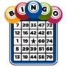 | 31  10:00am Little Learner’s Halloween Party (GR)  2:00pm Bible Study & Hymn Singing (GR) | Little Learner’s Preschool  Monday – Thursday  9:30am – 11:30am  House 1

