**H.E.L.L.0.**

**{Harwood Manor’s. Events. Life. Leisure. Opportunities.}**

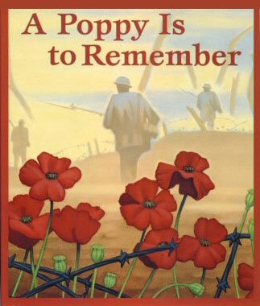

**NOVEMBER 2022**

**We Will Remember Them**

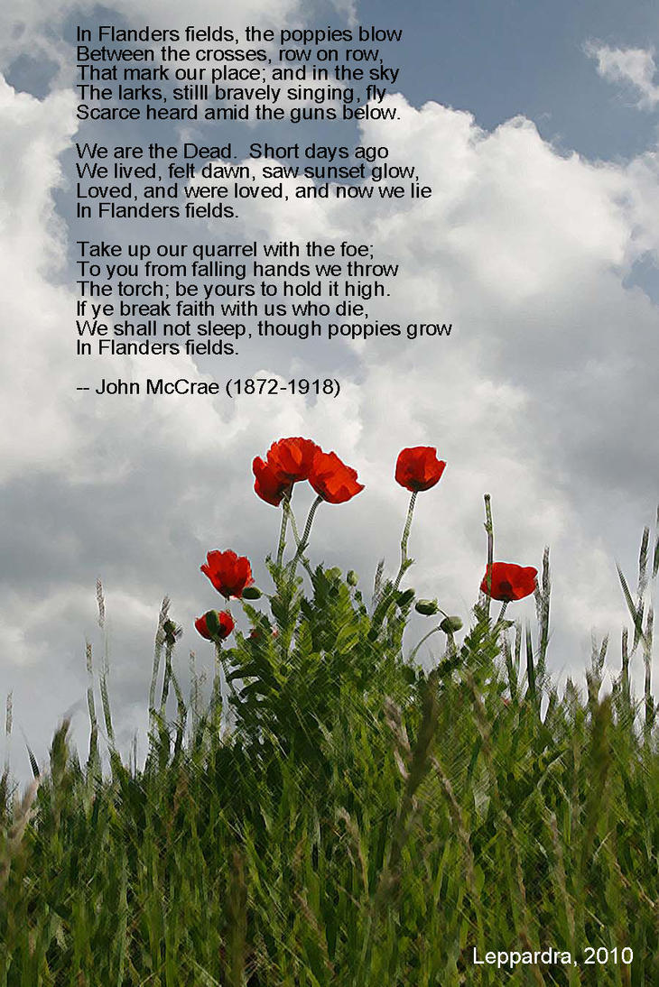

**We would like to extend a warm Welcome to**



**Howard & Mary Mattila - House 3**



[This Photo](https://www.pngall.com/farewell-png/download/17499) by Unknown Author is licensed under [CC BY-NC](https://creativecommons.org/licenses/by-nc/3.0/)

**Wishing Health & Happiness to Kay Sidebottom as she moves into Biggar, Sask.**

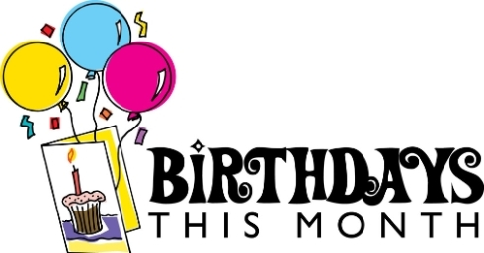

**Grace Drury November 6th., 1925**

**Hazel Illingworth November 7th., 1938**

**Bernadine Nash November 24th., 1927**

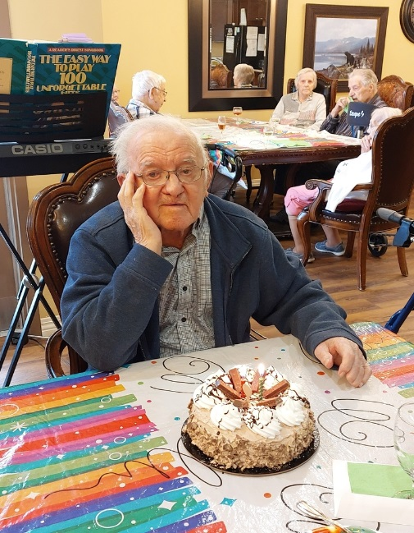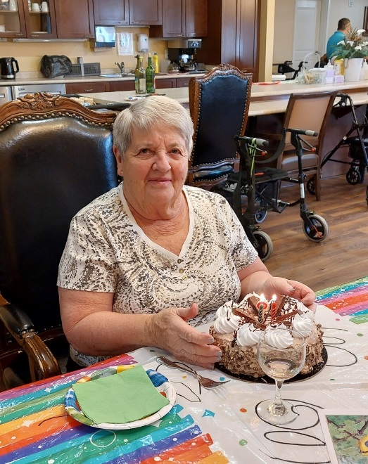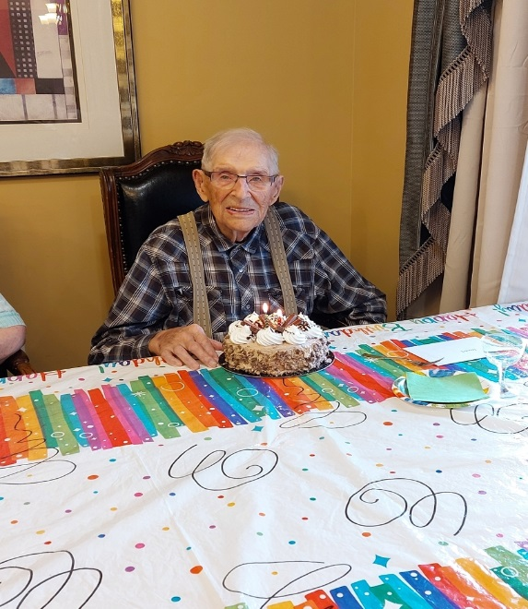



Very Special Birthday Wishes to Joe Charabin who turned 100 years on Oct. 29th2022

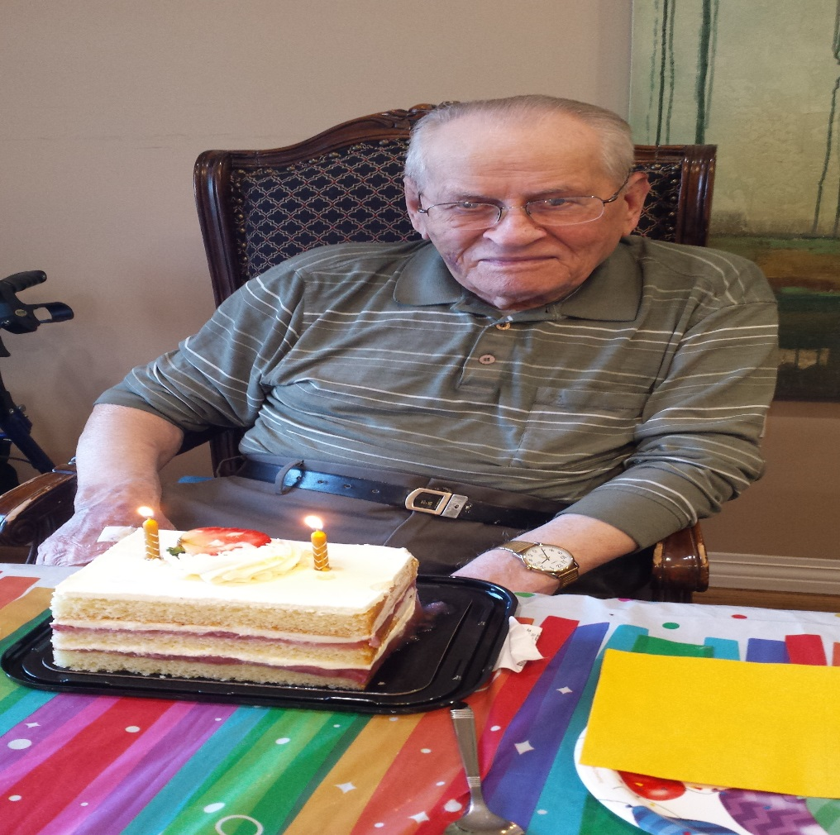

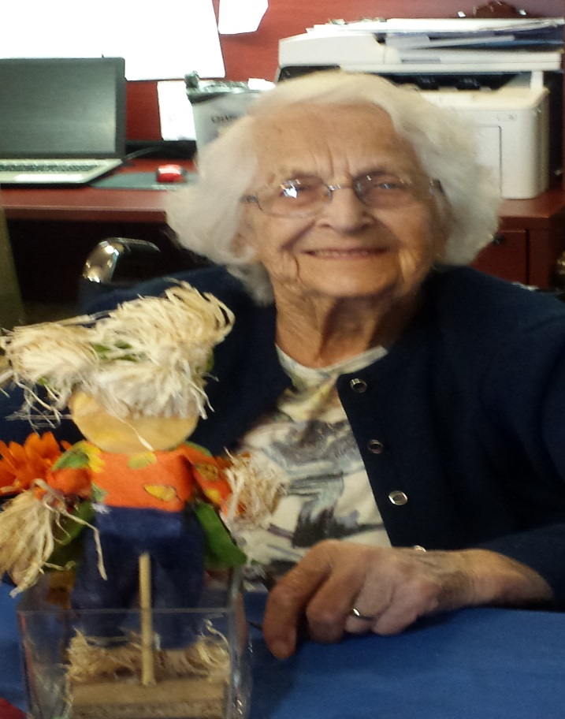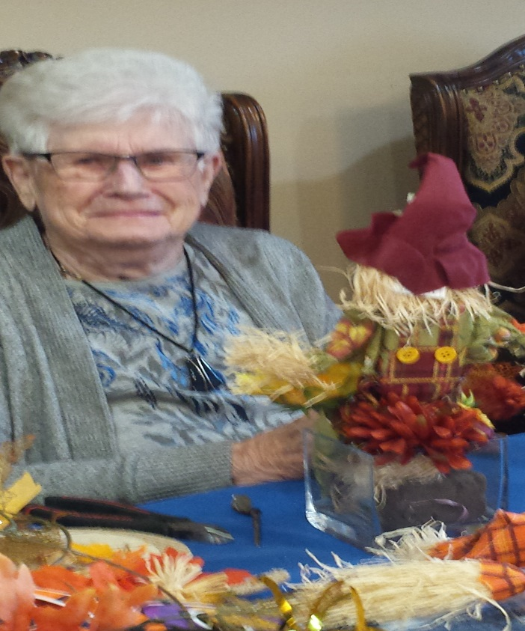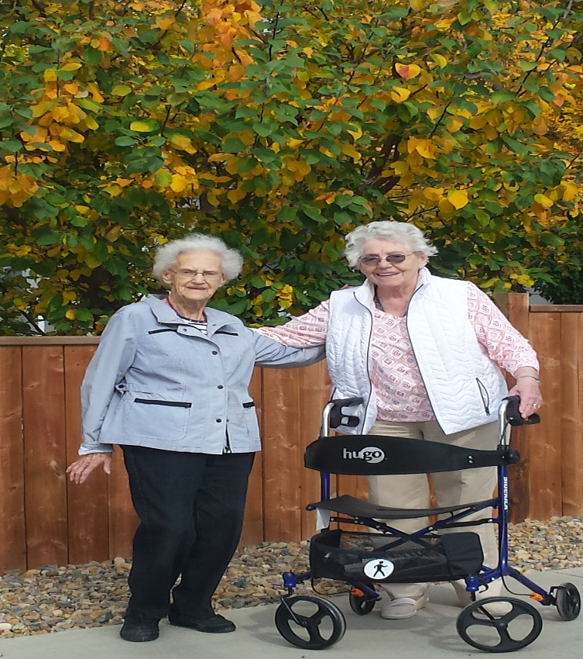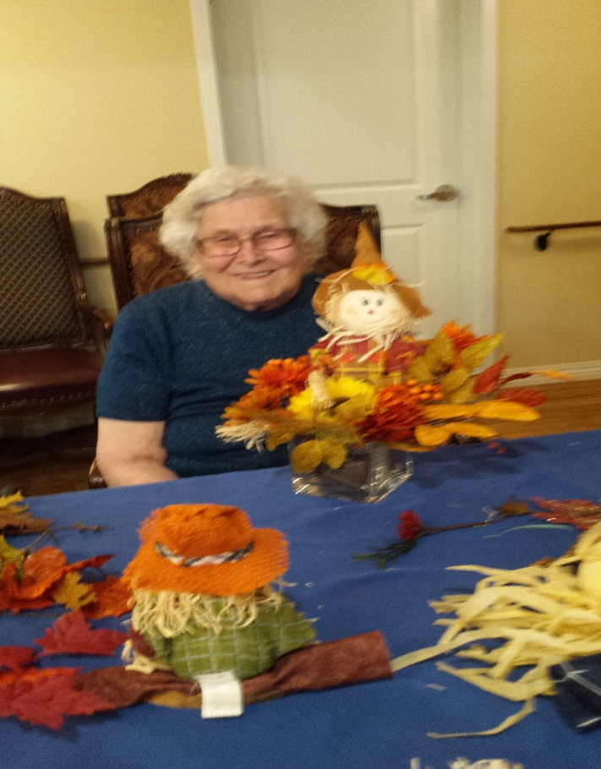**Our Thanksgiving Table Center Pieces..**

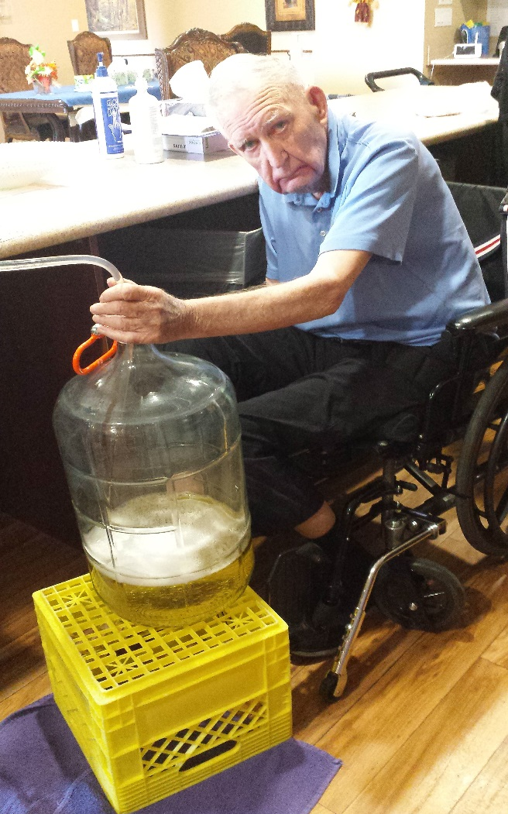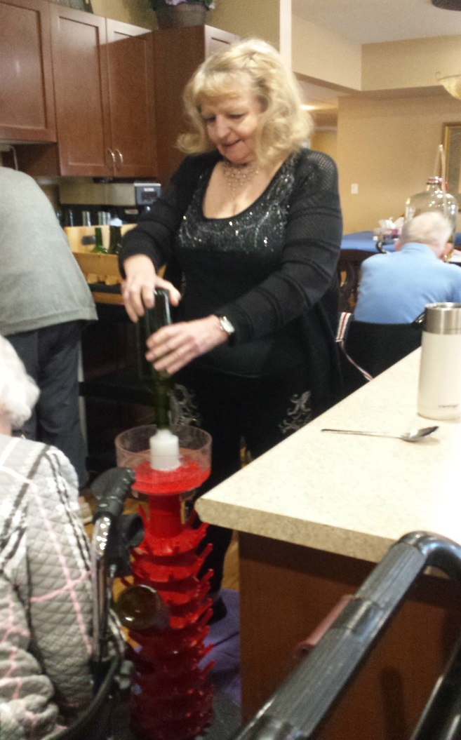

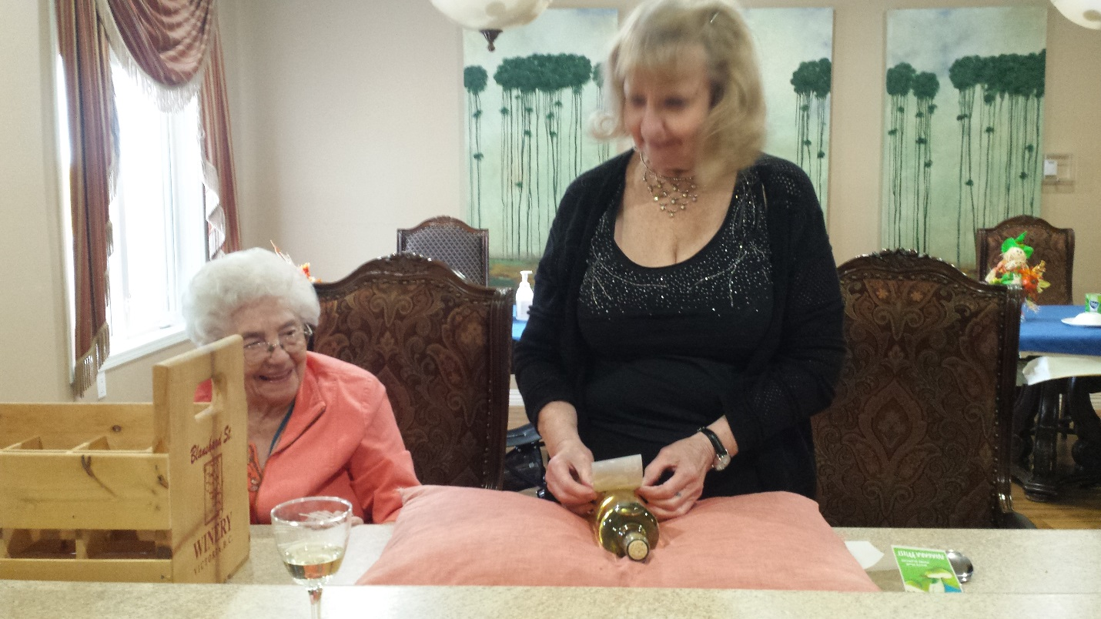

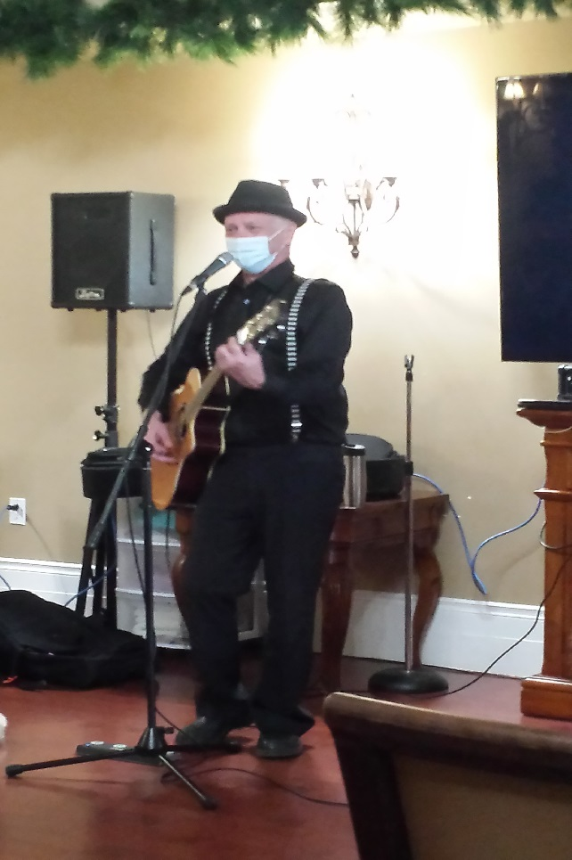Thank-you Brian Kendall for the wonderful afternoon of listening, and singing to “The Oldies”.



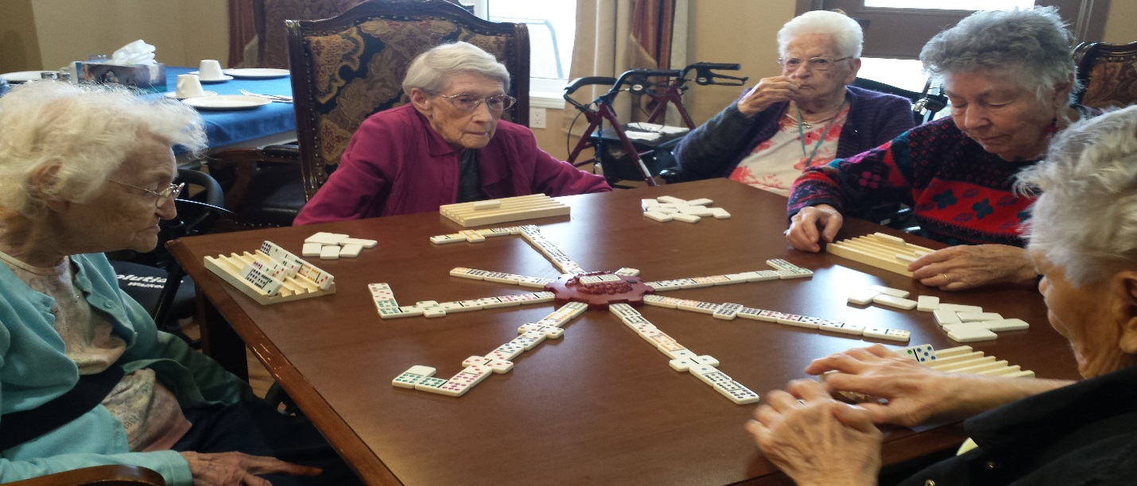Just a “Friendly” game of Dominoes